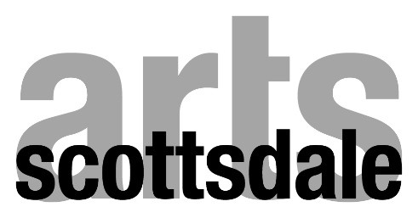

FY 2021-2022 Community Arts Grant Deadlines

Press Release
Application Opens
Application Deadline
Panelist Orientation*
Applications to Panelists
Panelist Comments due
Panel Review*
Funding Distribution
Friday, May 21st @ 10 AM
Tuesday, June 1st @ 10 AM
Friday July 9th @ 11:59 PM
Tuesday, July 13th @ 10-11 AM
Wednesday, July 14th @ 5:00 PM
Monday, August 23rd @ 5:00 PM
Friday, August 27th @ 9:00 AM to 2:00 PM
Early September

*Meeting held via ZOOM or in-person TBD

